Part 1

1. Create a simple database on EC2 which will contain a shipment table, a customer table as well as an item table.

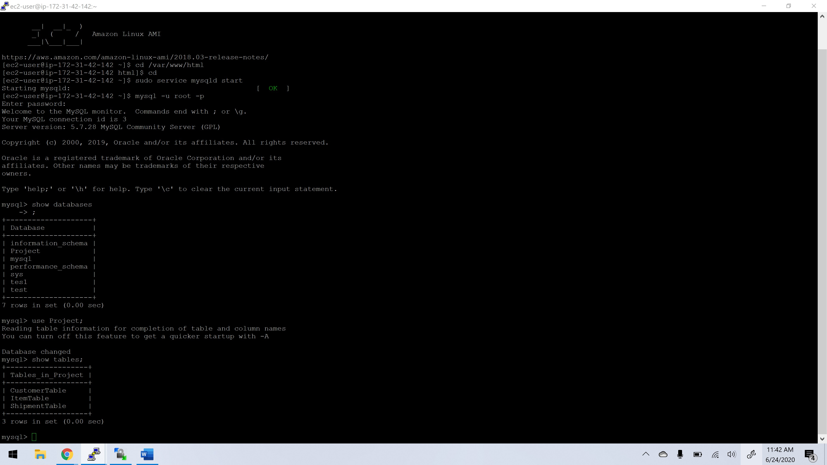

1. Populate all tables with some sample data. You can use Mockaroo.com to generate data if you like. I have posted a tutorial on this.

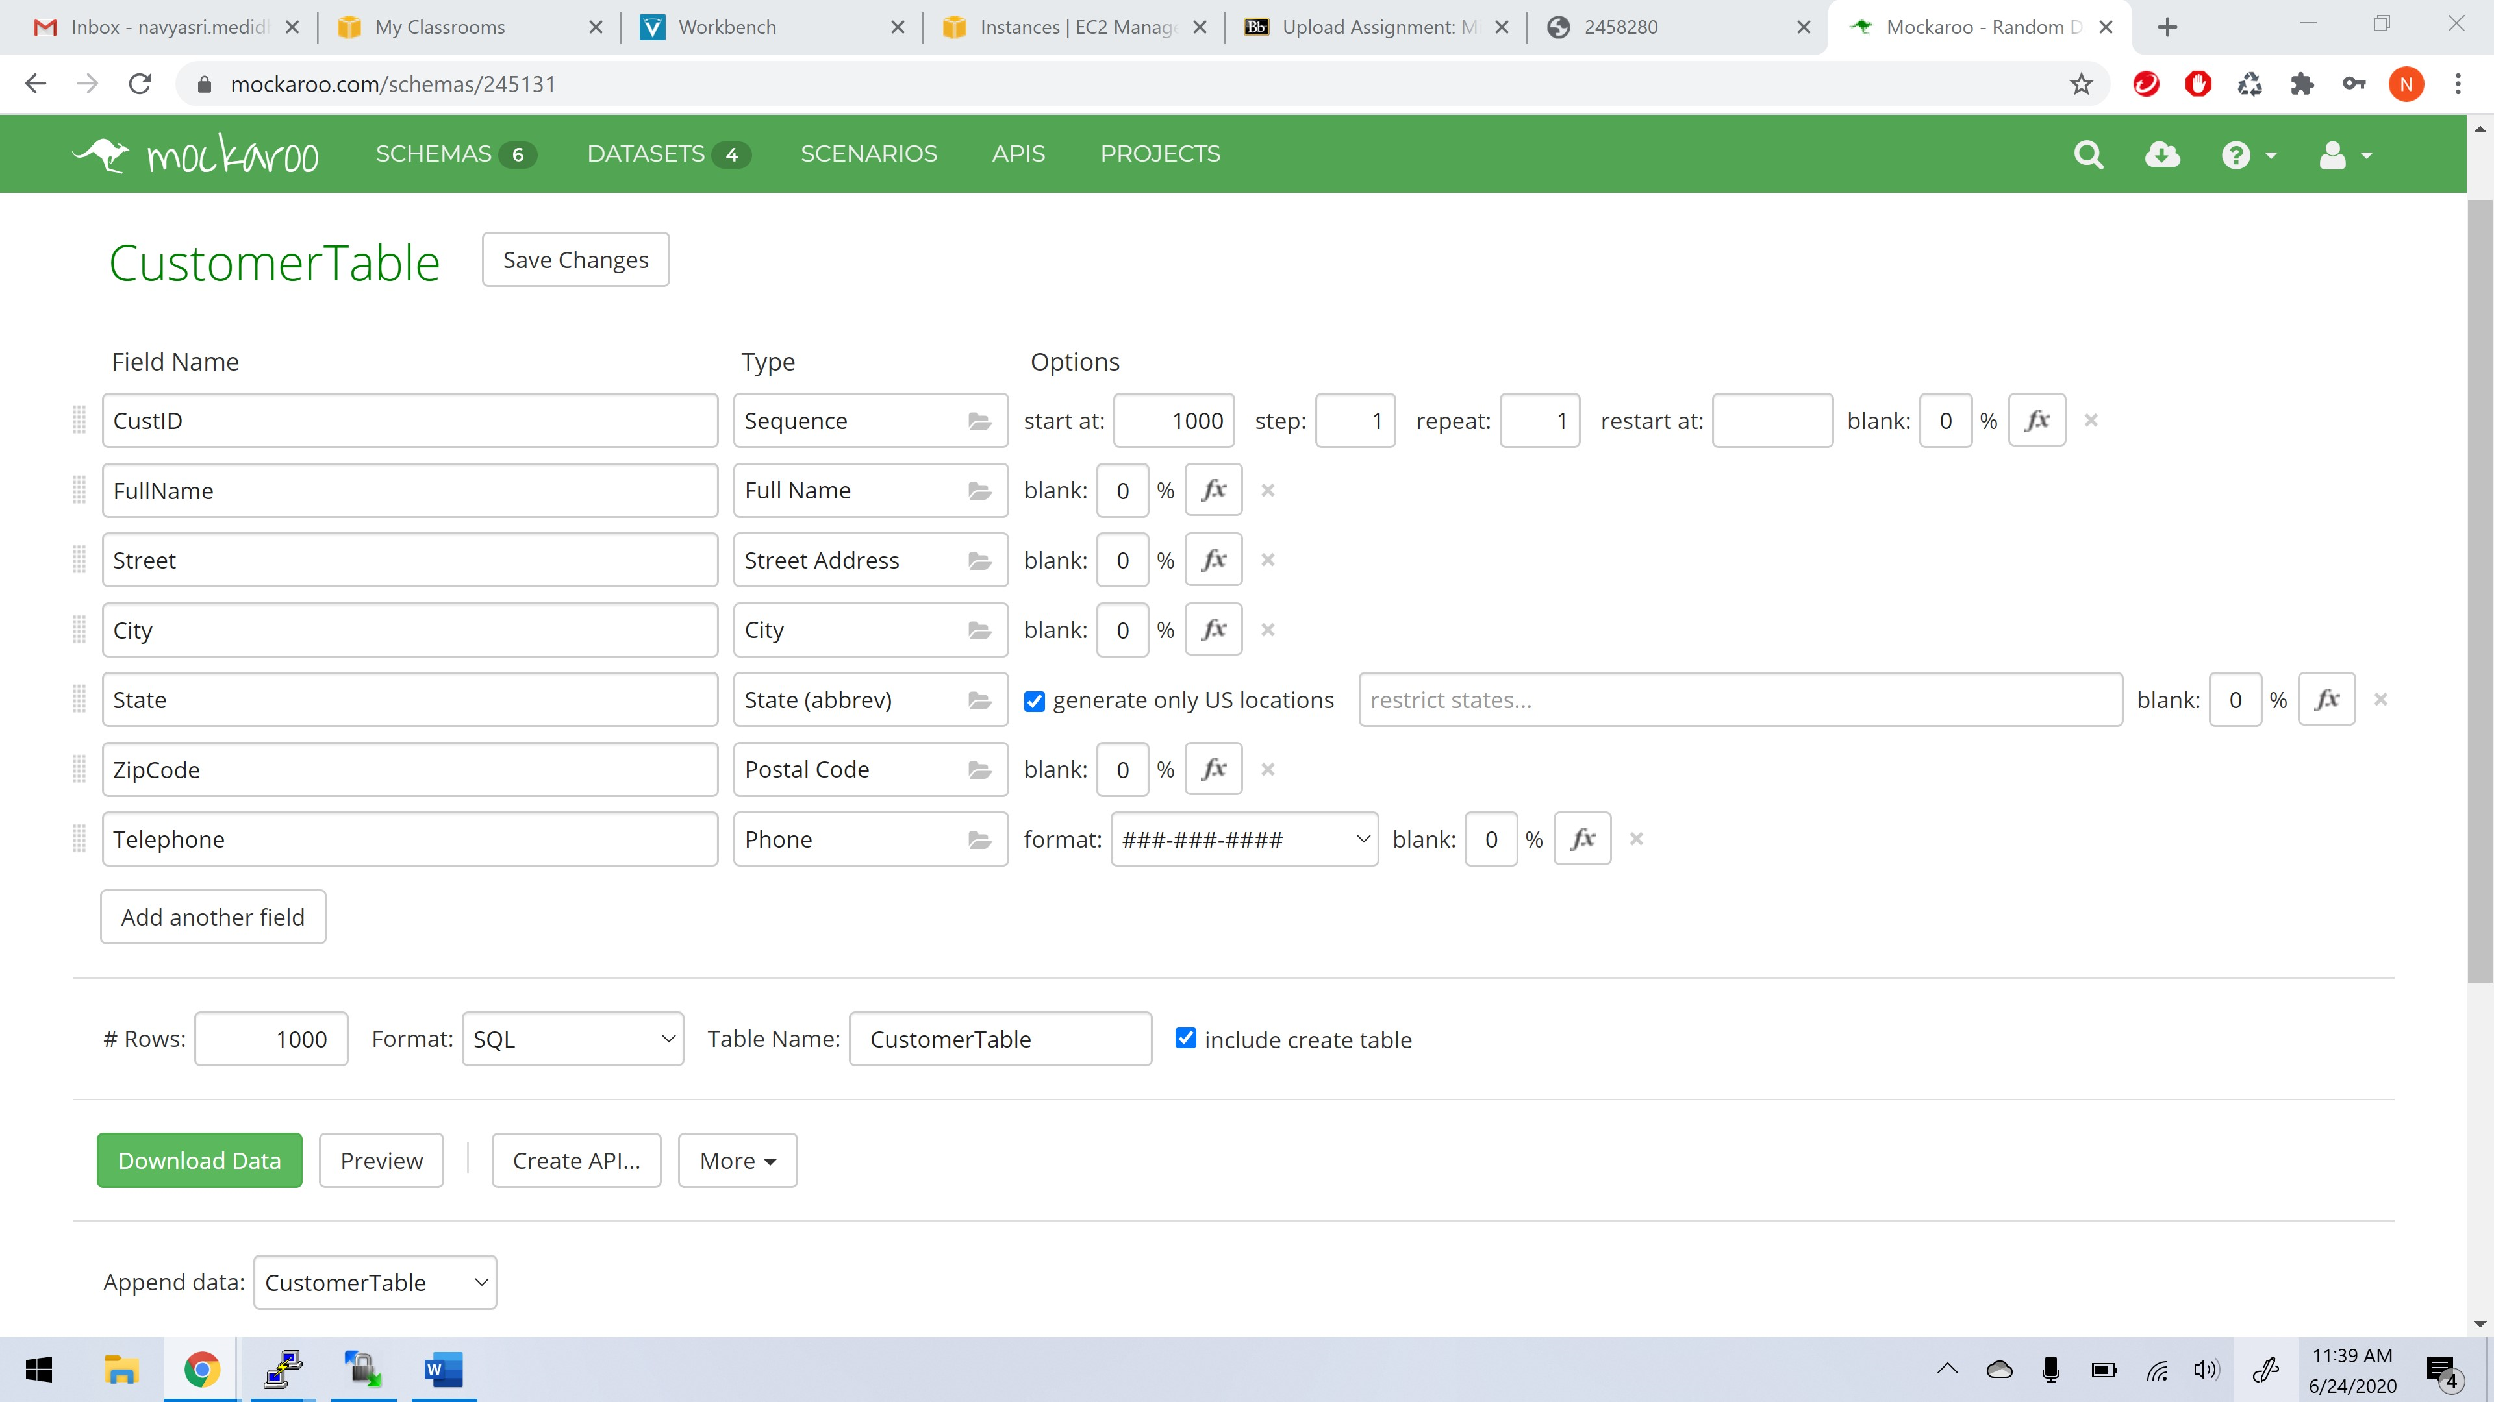

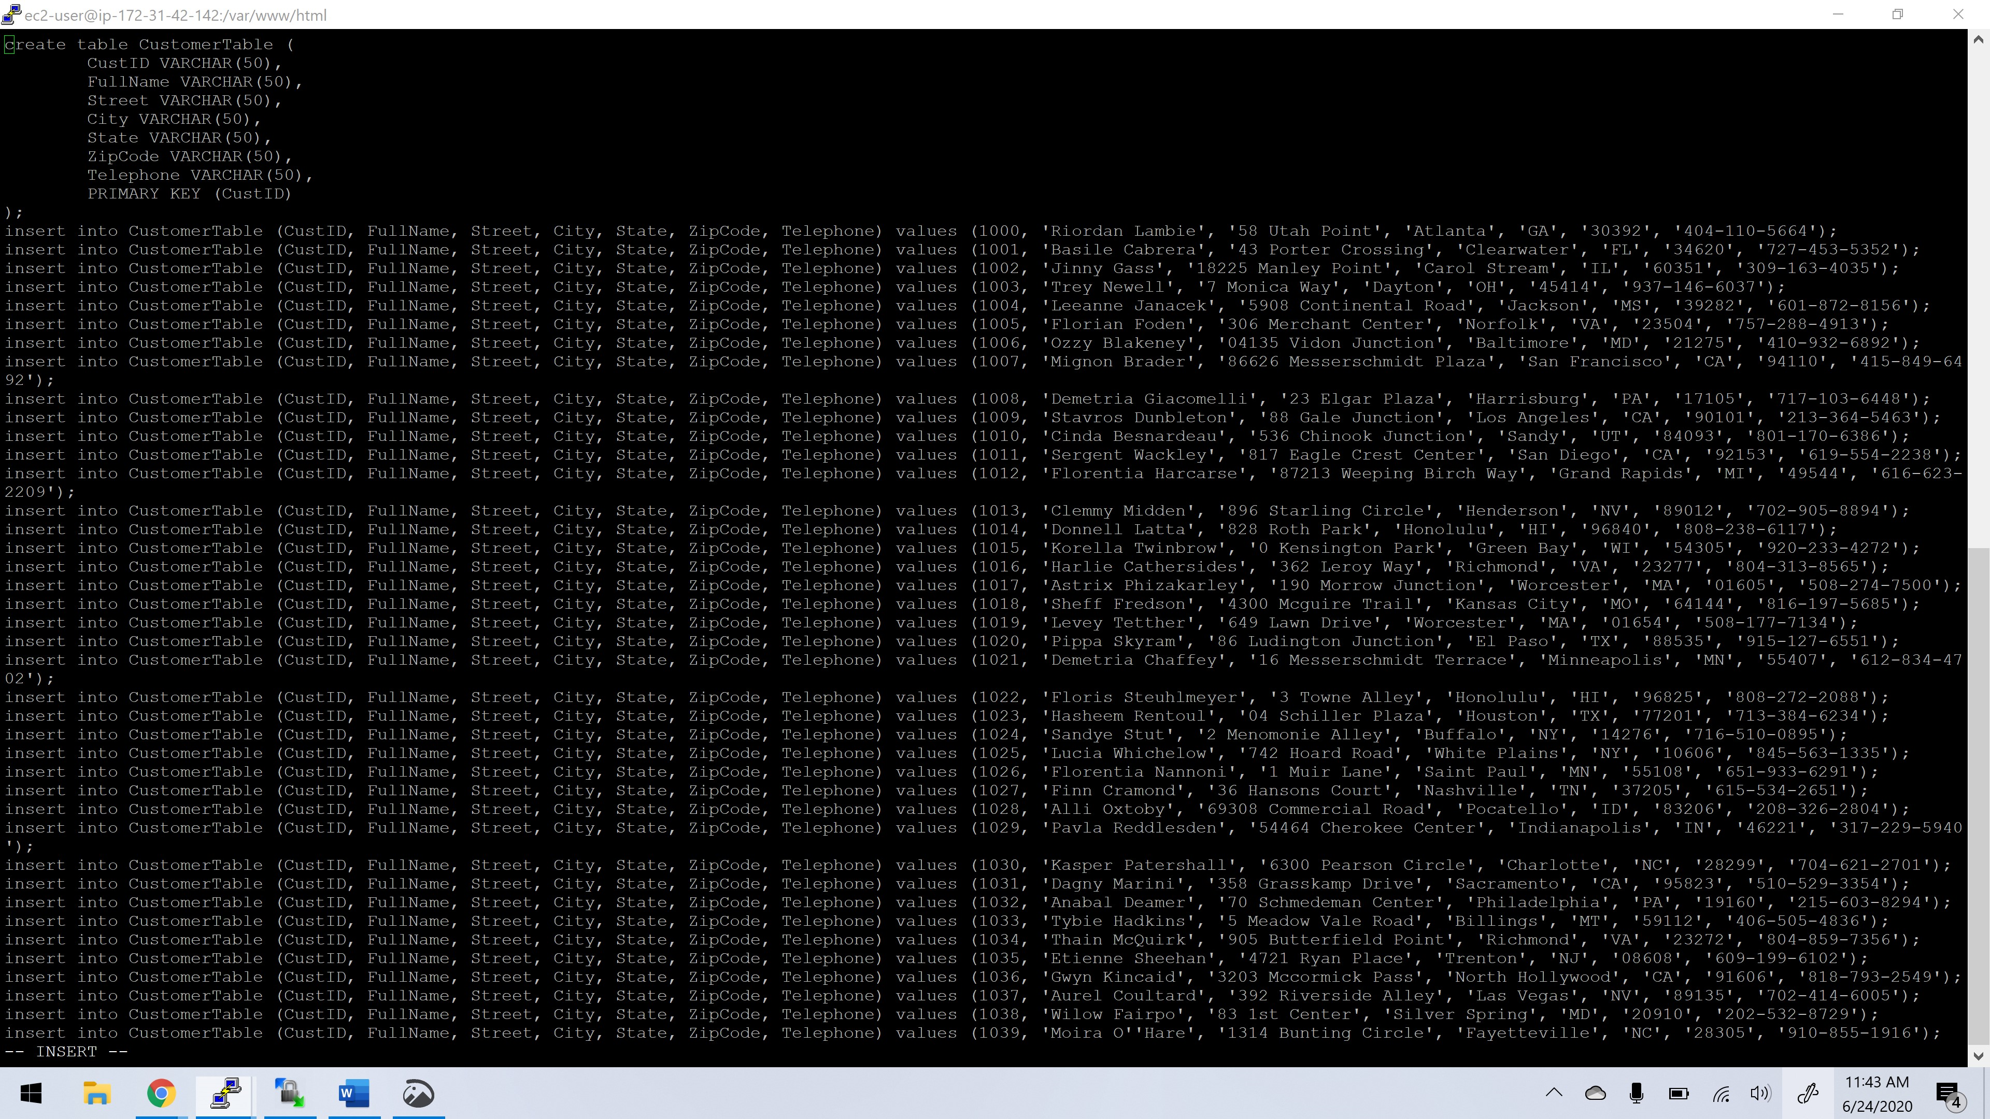

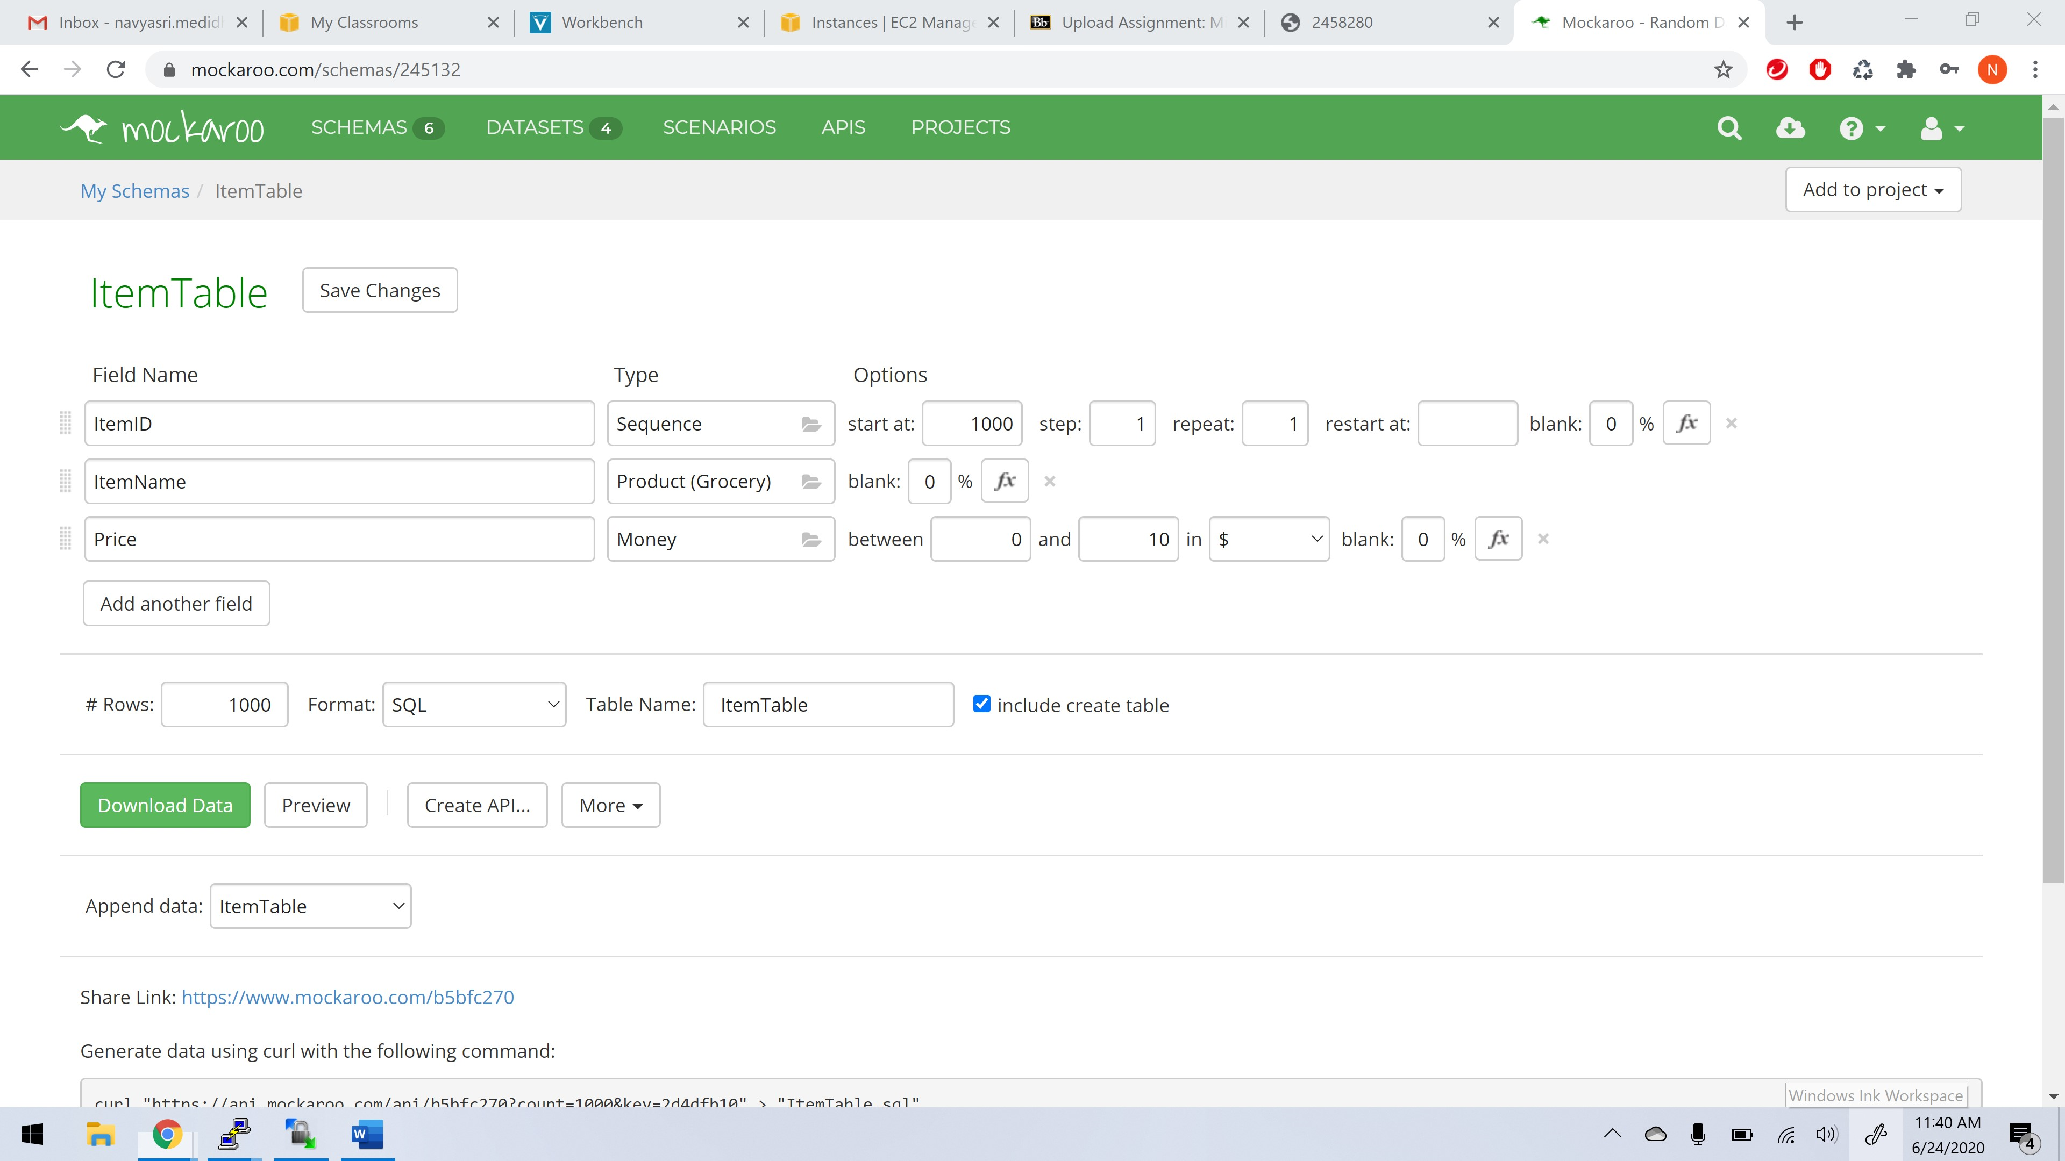

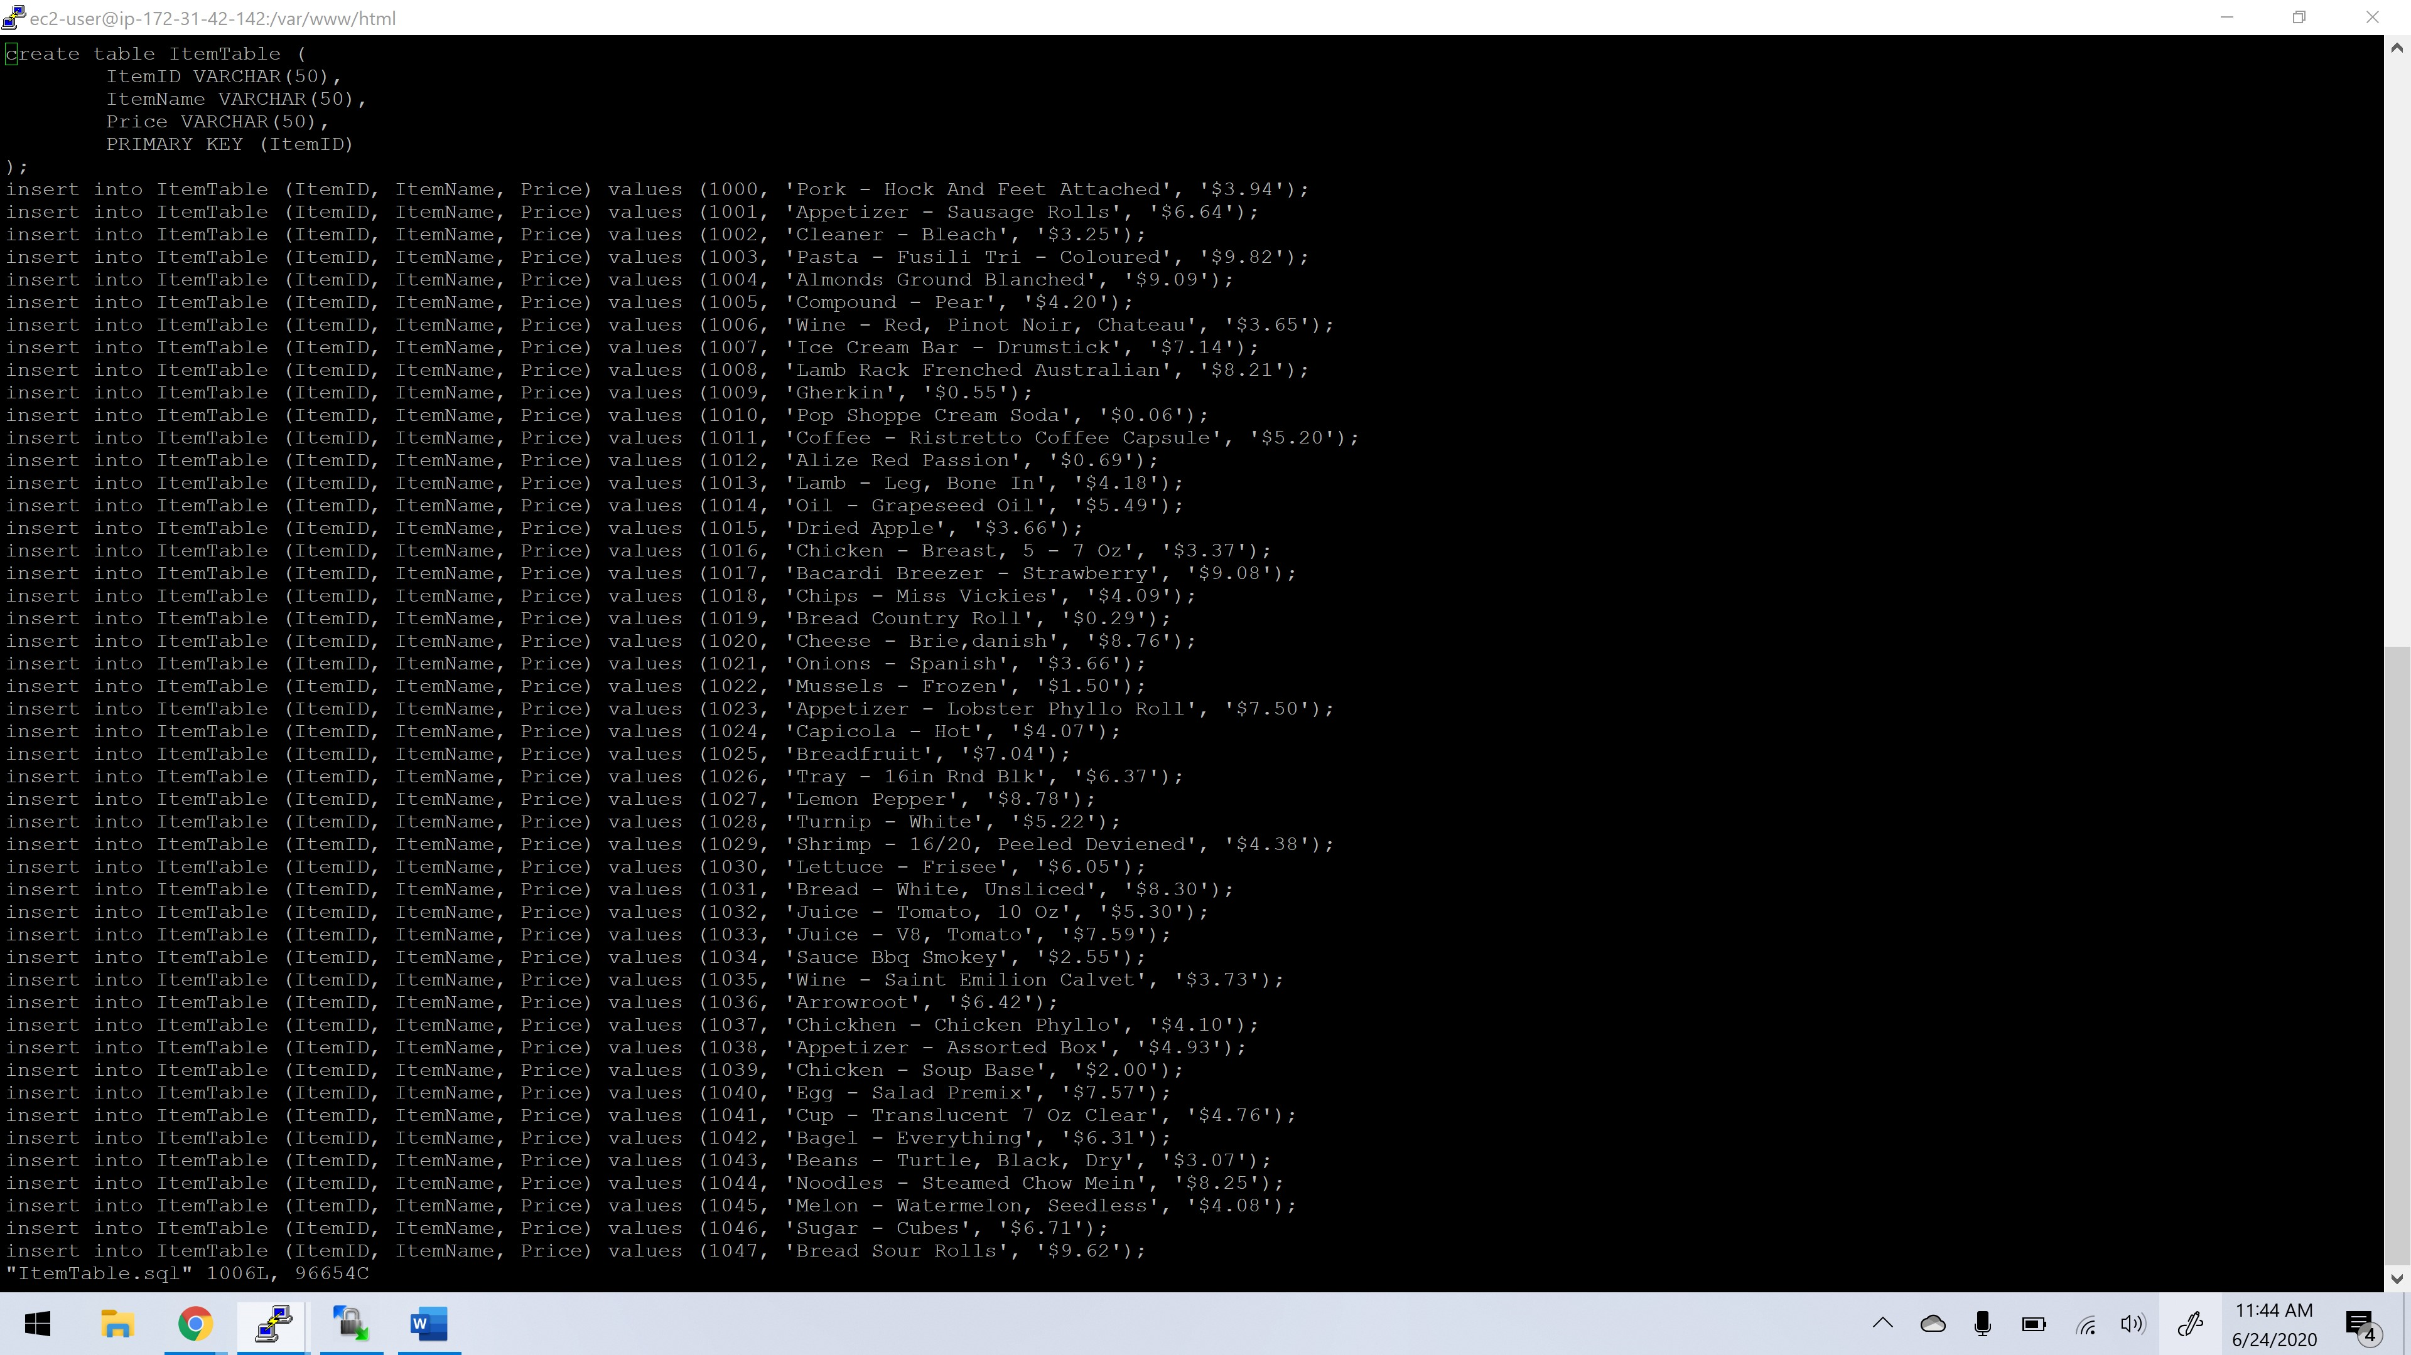

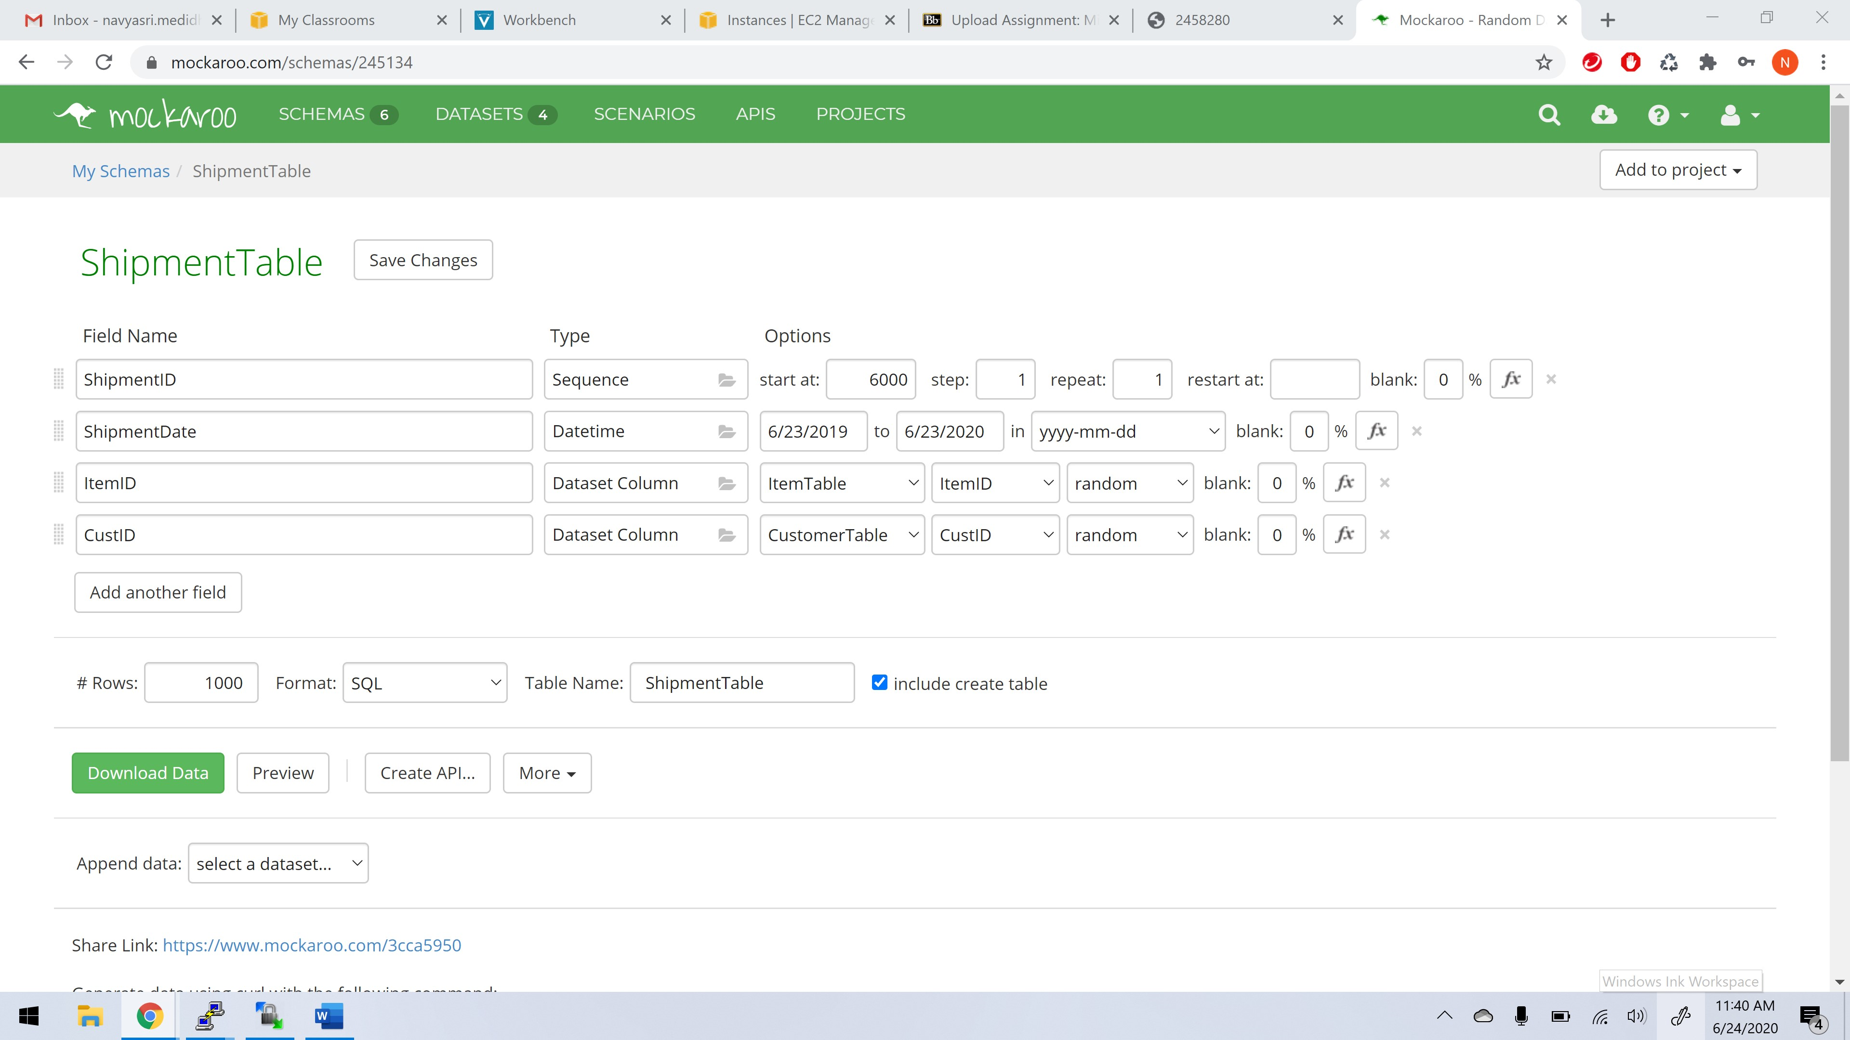

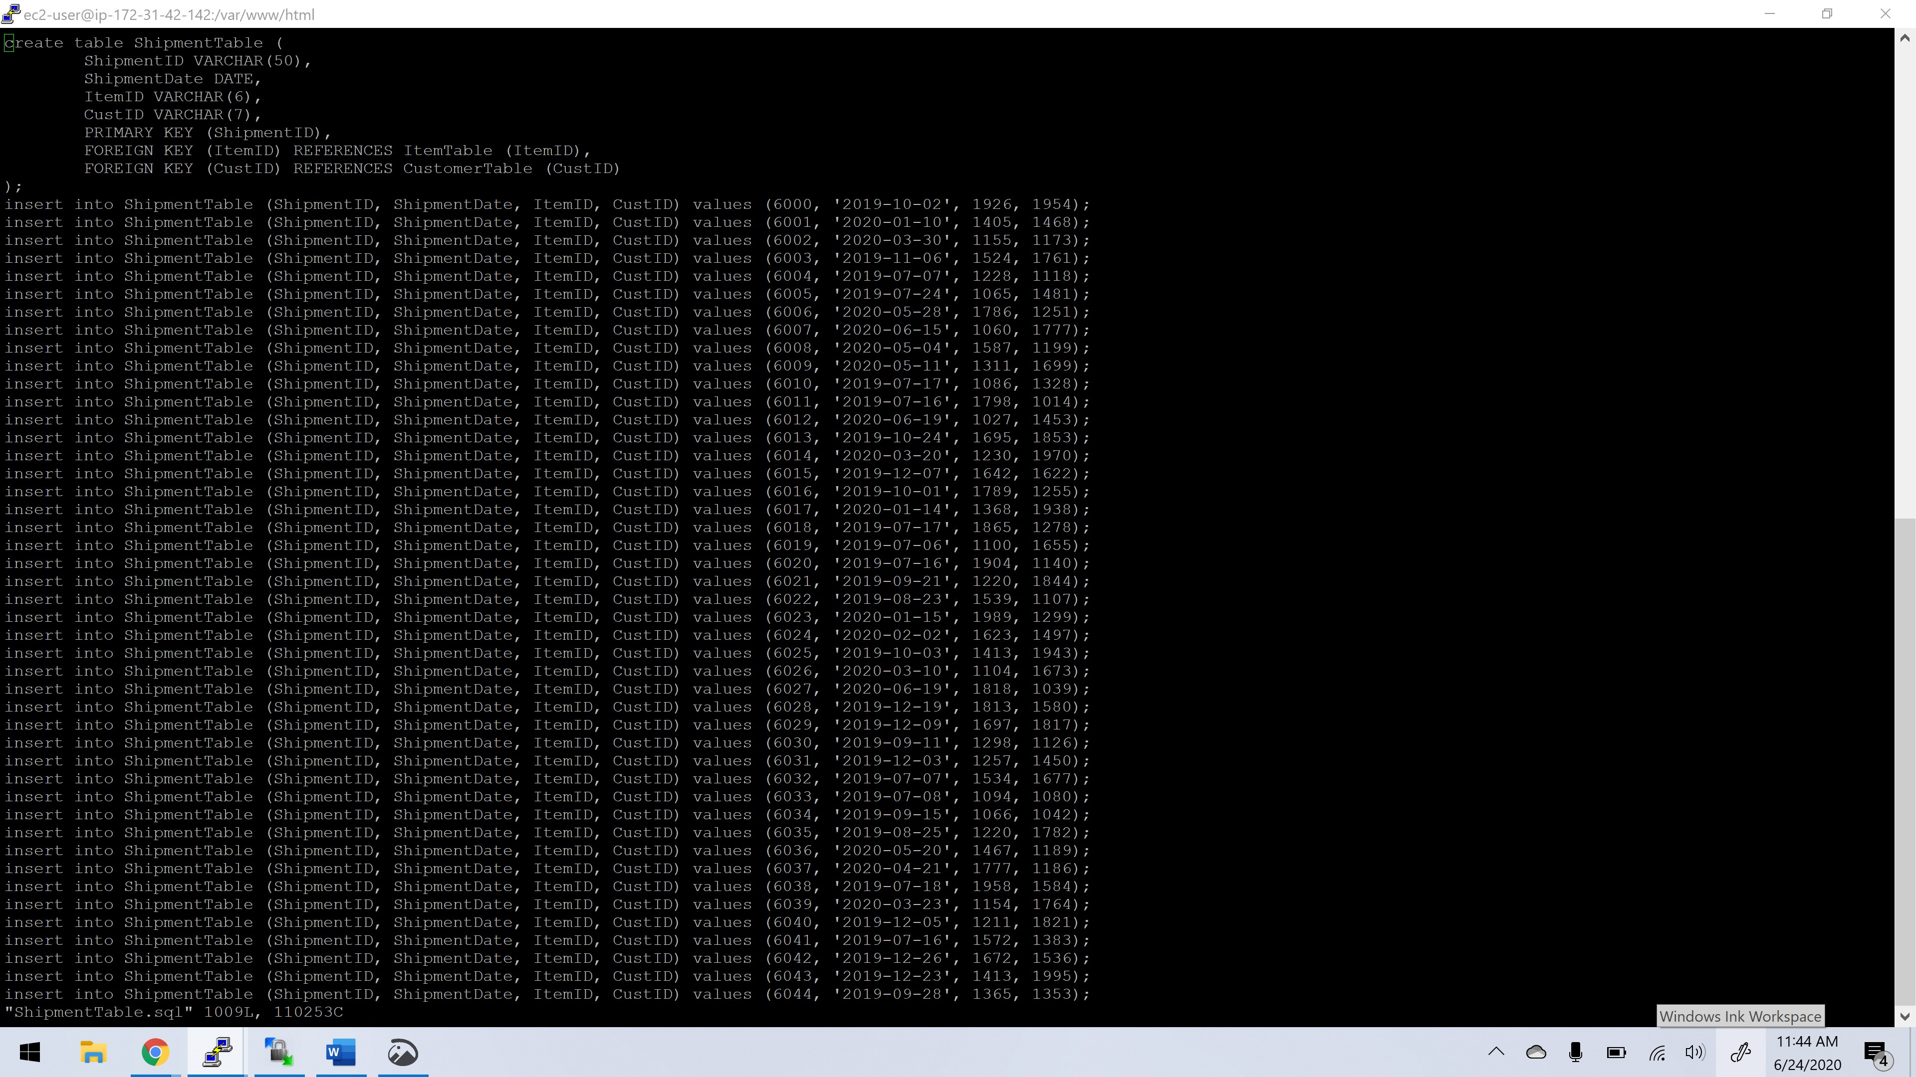

1. Write a couple of Web pages which use AJAX. One should allow the user to lookup all the orders for a customer. The other should list all items.

Please run “mainminiproject.html” file for the final output.

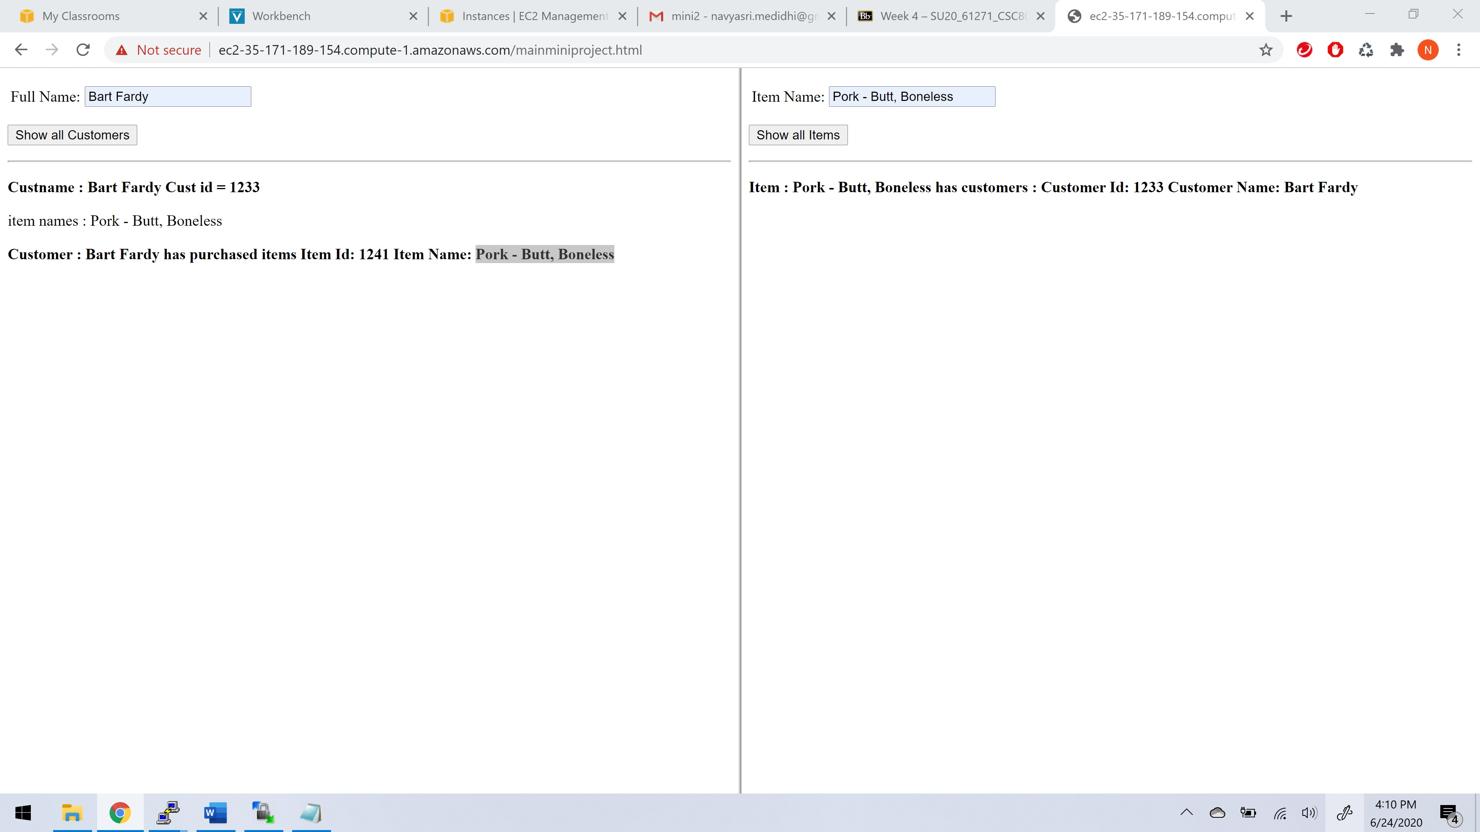

1. Submit your code as well as your schema for this part. Please note that all of this should be run in the Cloud on EC2.

**Please find the files in the zip file as named below:**

1. **CustomerTable.sql**
2. **customer.html**
3. **dumpCustomer.php**
4. **queryCustomer.php**
5. **ItemTable.sql**
6. **dumpItem.php**
7. **queryItem.php**
8. **item.html**
9. **mainminiproject.html(final output)**
10. **ShipmentTable.sql**